





Table Of Contents

1. Cover Sheet Page 1
2. Table of Contents Page 2
3. Brief Descriptor Page 3
4. Logo Design Page 4
5. Style Tile Page 5
6. Flow Chart Page 6
7. Wireframes Page 7
8. Design Comps Page 13
9. Milestones Page 19
10. Functionality Page 20



Brief Descriptor

About

Aion, adeptly named after the Greek god of eternity, is an industry first time management site dedicated to the freelance industry. The site allows users to manage their time in an effective and seamless manner. Users can add projects, tasks associated with those projects; client lists among many other amazing features.

The online interface allows you to manipulate those tasks, set priorities, add or edit info, and sort the tasks numerous ways.

Target Audience

Aion will prove useful to just about anyone with a busy life. It will provide particularly useful to the freelance media industry, or any other industry with extremely fickle schedules. Never miss another shot or double book a date again with this intuitive and robust program.



Logo Design



Standard Logo

Alternate Logos



Infinity Symbol without Words Company Name

Colors





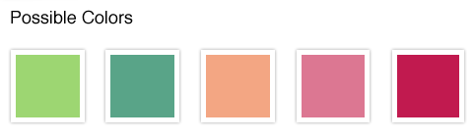Style Tile

#9DD672 #59A488 #F3A683 #DC7792 #C11A4F

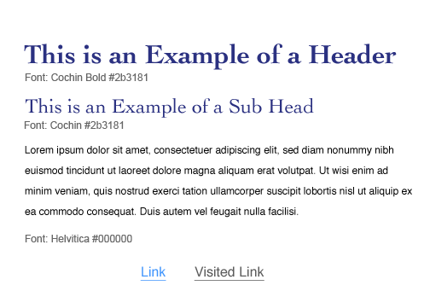

Typography Treatment

Buttons and Tooltips





Flow Chart

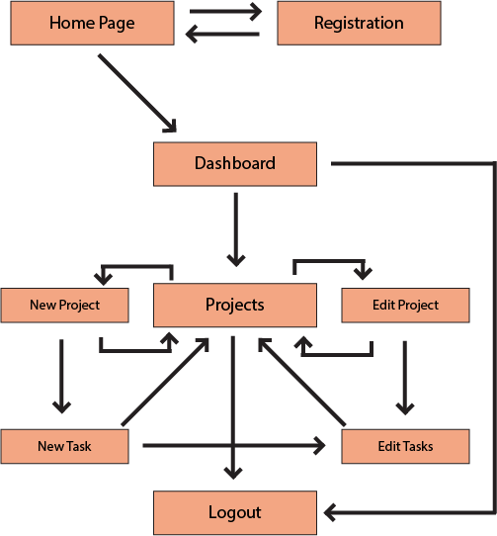



Milestone Chart

Complete Learning Objectives for Week 2 7 Feb 2014

Complete HTML and CSS site first draft 10 Feb 2014

Test, modify, and finalize HTML and CSS 12 Feb 2014

Submit finalized work to instructor 14 Feb 2014

Complete Learning Objectives for Week 3 15 Feb 2014

Build JavaScript Functions of site 18 Feb 2014

Test, Modify, And Finalize JavaScript 20 Feb 2014

Submit Finalized work to instructor 21 Feb 2014

Review and Test functionality site 22 Feb 2014

Refine visual elements of the page 24 Feb 2014

Refine efficiency of JavaScript 26 Feb 2014

Submit Final and receive an outstanding grade 28 Feb 2014



Functionality Bullets

These are my 3 chosen “optional” features.

* Dashboard Page
* Clients
* Drag & Drop